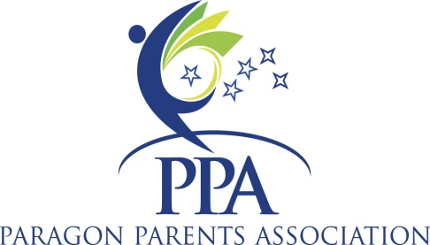

2012 All Star Challenge Entry Form

Entry Deadline: March 16, 2012

Scratch/Swap Refund Deadline: March 31, 2012

Meet Name: | 2012 All Star Challenge | Check payable to: Paragon | Mail to: Paragon
Meet Date: | April 29, 2012 |  | 1410 Central Park Blvd  Fredericksburg, VA 22401
Meet Site | Paragon Training Center | 1410 Central Park Blvd | Fredericksburg, VA 22401
Attending Club Name |  | Phone: | Email:
Club Address: |  | City: | State:
Zip: |  | Fax: | Alt Email:
Coaches Name: |  | USAG #: | Safety Exp Date:
Coaches Name: |  | USAG #: | Safety Exp Date:

 | Name | USAG# | Level | Birthdate
1
2
3
4
5
6
7
8
9
10
11
12
13
14
15
16

Meet Director’s Use
Date Received |  |  |  | # of All Stars:__ x $70.00 per gymnast | $00.00
Check Number |  |  |  | # of optional:__ x $60.00 per gymnast | $00.00
Short / Over |  |  |  | Total | $00.00
I acknowledge that I am familiar with the USAG Rules & Policies. I have read and understand all information pertaining to this meet. I understand that I am responsible for the correct names, age groups, birthdates, and USAG numbers of gymnasts.
Gym Representitive Signature: ______________________________________

